Benefits and Administration Team (BAAT) Release Plan

Read all of the background material and supporting documents on the BAAT project found on eLearning. Provide the following information and answer the questions listed below.

Part 1 - Project Charter (20 points)

1. Create a project charter based on information in the SimAgile Orientation guide and the Company Policies document found on eLearning. Your project charter should include the following sections.

|  |  |
| --- | --- |
| **GENERAL PROJECT INFORMATION** | |
| **Project Name** | Benefits and Administrative Product |
| **Project Description** | The Benefits and Administrative product work is part of the human resource department’s effort to provide more immediate access and control to individual employees over their own personal information. This web site is needed to upgrade the HR functions and to help it be more responsive to the needs of the Uniworld employees.    The customer of this website is the Human Resources organization of Uniworld. The end user is Uniworld's employees. They will have input into the website development and provide important feedback during the project. The company has budgeted $50,000 dollars for the development of the portal. HR has stated that it needs a minimal viable website within 2 months in order to coordinate the website launch with the annual open enrollment and mailing and emailing of supporting brochures to all employees. |
| **Project Purpose** | To provide secure employee access to all personal benefits and payroll information and self selections. The site will also provide all necessary background information and constraints. |
| **Measurable Objectives and Success Criteria** | Measurable Objectives:   * The website must be capable of responding to requests in less than 2 seconds. * The website must work with all the major browsers. * The website will be accessible 24 hours a day, 7 days a week. * The website can be utilized by employees and spouses from home, by multiple branch office locations and by employees on the go. * The website will be a single access point for all employee benefits including medical, dental, prescription, vision, flex-spending accounts and 401K options.   Success Criteria:   * The minimal viable project is delivered by the end of Sprint #4. |
| **Summary Milestone Schedule** | * Project Start Date: 5/1/2023 * MVP Release (Release 1): 5/26/2023 * v2.0 Release (Release 2): 6/09/2023 * v3.0 Release (Release 3): 6/23/2023 * v4.0 Release (Release 4): 7/14/2023 |
| **Project Budget** | $50,000 |
| **Name of Product Owner** | Noshirwaan Homiyar Aibada |
| **Name of the Project Sponsor** | Michael Russell, VP Human Resources |
| **Name of the Scrum Master** | Shekhar Subedi |
|  |  |

Part 2 - Product Vision (20 points) (Musa)

1. Read all of the background material on the BAAT project and develop a vision statement. The vision statement should be clear concise description of the product clearly describing the value of the product. Please refer to the class notes for advice and tips on creating a good vision statement.
   1. Our vision is to deliver a site that will house both benefits and payroll data, which will create an awesome experience and be accessible to all our employees and their families. The site will be intuitive to use and will require little to no training. The site will be accessible anywhere, at any time, will be able to respond to requests within 2 seconds, and able to work on all the major web browsers. The site will be optimized for employees' access and certain employee benefits and payroll information will be restricted and can only be updated by authorized HR personnel. The minimal viable product (MVP) of the website will be available within 2 months to coordinate the website launch with the annual open enrollment and mailing and emailing of supporting brochures/documentation to all employees.

Part 3 - Release Plan (20 points)

1. Analyze all of the user stories in the initial product backlog and create a product roadmap/release plan. The product roadmap should clearly identify the release date for the minimally viable product and the release date(s) of any subsequent versions. When developing your release plan, assume an average velocity of 30 story points per sprint and a total of four two-week sprints. How many releases total do you have planned?
   1. 4 releases
2. List the date of each release and provide a short, descriptive name for each release.

|  |  |  |
| --- | --- | --- |
| Release Plan Schedule | | |
| Project Start Date: 5/01/2023 | | |
| Releases | Name | Date |
| Release 1 | MVP Release | 5/26/2023 |
| Release 2 | v2.0 Release | 6/09/2023 |
| Release 3 | v3.0 Release | 6/23/2023 |
| Release 4 | v4.0 Release | 7/14/2023 |

Part 4 - Grooming the Product Backlog (20 points)

1. Groom your entire product backlog and describe the approach you used to groom the product backlog. Specifically list and describe the rules you used to prioritize your product backlog.
   1. Sort user stories by MVPs (Z-->A)
      1. We wanted to ensure that the MVP is delivered as soon as possible, and thus we focused on user stories pertaining to MVP first. Hence, using the Sort & Filter option in Excel, we placed all MVP user stories at the top.
   2. Calculate Business Value per story point
      1. We wanted to deliver the most amount business value per story. Hence, we created a new column and calculated the business value per story point for each user story. (Formula: Total Business Value Point/ Total Story Points)
   3. Sort user stories by descending order of Business Values per story point
      1. We wanted to complete the user stories with the most amount of business value per user story point first. Using the Sort & Filter option in Excel, we added a second level to the sort, in which after the MVP is sorted, Excel orders the user stories by the most business value per story point at the top, and the lowest at the bottom.
   4. Assigning less than 30 story points for the first two sprints
      1. We noticed how the MVP is mostly completed in the first two sprints. However, we did not want to maximize velocity (30 story points) in the first two sprints since we do not want to overload the developers with user stories. Moreover, we wanted to provide a buffer in case there are any issues when developing the MVP user stories. Hence, to sprint 1 we assigned 27 user stories and to sprint 2 we assigned 29 user stories.
   5. Maximize the velocity for Sprint 3 and 4
      1. For sprints 3 and 4, we tried to maximize velocity by including as many sorted user stories as possible without exceeding the limit of 30 user story points.
   6. Rearrange user stories for Sprint 5 and 6 to maximize velocity
      1. The last four user stories were not important for MVP and have extremely low business value points per user story; hence, it did not matter how those user stories were sorted. User Story 29 and 31 were 13 story points, User Story 25 was 5 story points, and User Story 32 was 21 story points. We decided to combine them in sprints in a way that would maximize velocity, resulting in Sprint 5 having 26 story points and Sprint 5 also having 26 story points.
   7. Determine first release based on MVP delivery
      1. We wanted our first release to be after the MVP user stories are completed. Hence, we decided our first release would be after Sprint 2.
   8. Determine remaining releases by amount of user stories completed
      1. We noticed that Sprint 3 had many user stories to be completed. Hence, we added our second release after Sprint 3, since a multitude of new features would be added to the software. We did the same for Sprint 4.
      2. Sprint 5 and 6 only had two user stories each. Hence, we combined them both into one release.
2. Paste a copy of your groomed, prioritized product backlog below indicating which sprint each user story will be worked on.

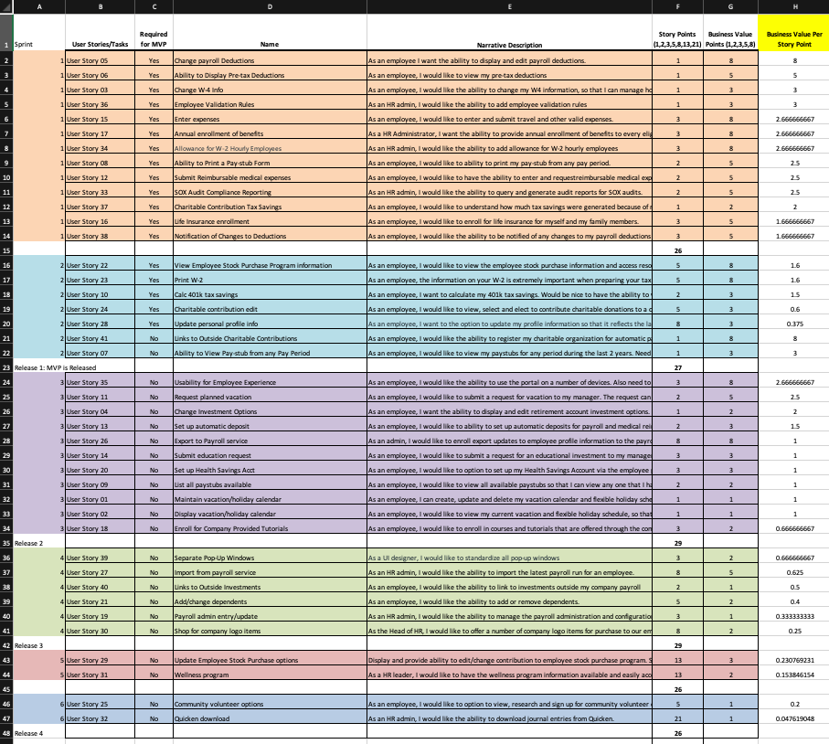

Part 5 - JIRA Software (20 points)

1. Create a free account on JIRA Software using the following link <https://www.atlassian.com/software/jira/pricing>. Use the information provided in parts 1, 2, 3 and 4 to create a new BAAT project on the JIRA Software platform. Use the JIRA Scrum template and import all user stories into the JIRA platform. Populate as much other content as possible for your project in JIRA. Paste a screenshot of each page of JIRA below.

This is the project’s Epics. They are further broken down into user stories. The chart shows how issues/user stories within each epic spread throughout the iteration/sprint.

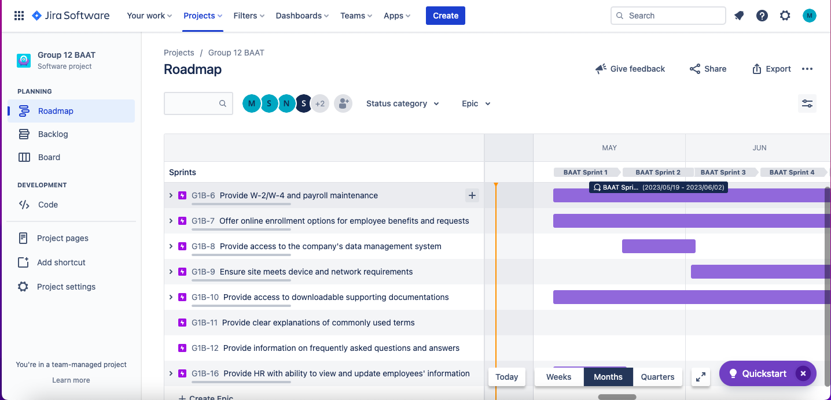

This screenshot shows the first sprint (BAAT Sprint 1), which shows the user stories within the sprint. Each sprint is 2-weeks long and the screenshot shows the start and end date, total estimated story points (or velocity) for the sprint. It also shows each user's story with the epic name to which they are assigned, the estimated story point, and the team member whom the story is assigned.

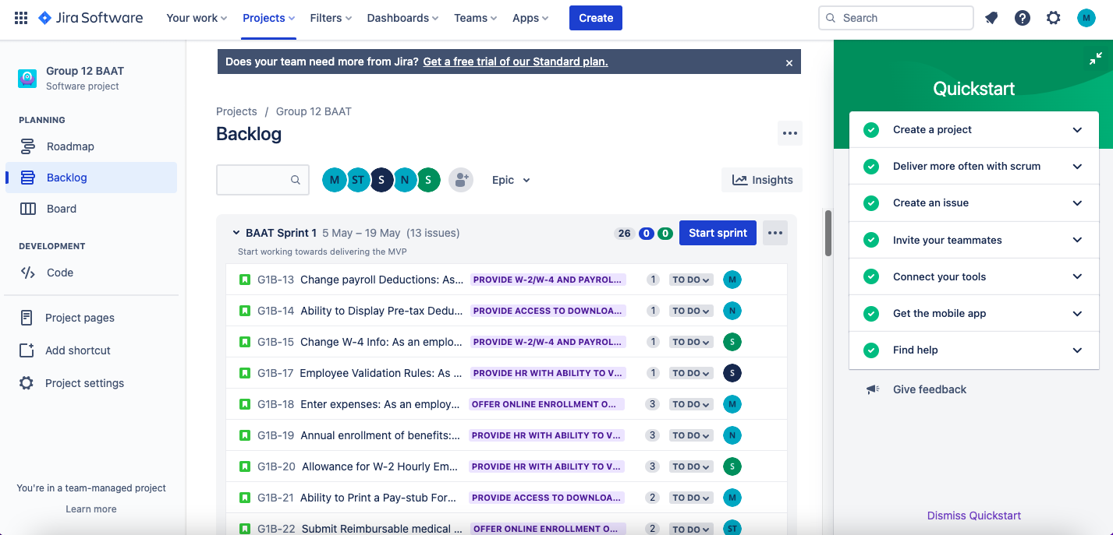

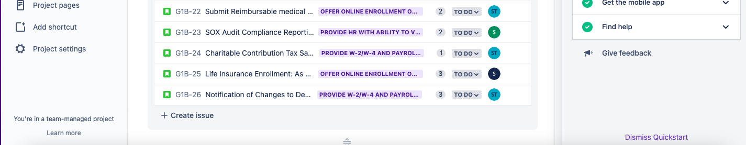

Sprint 2

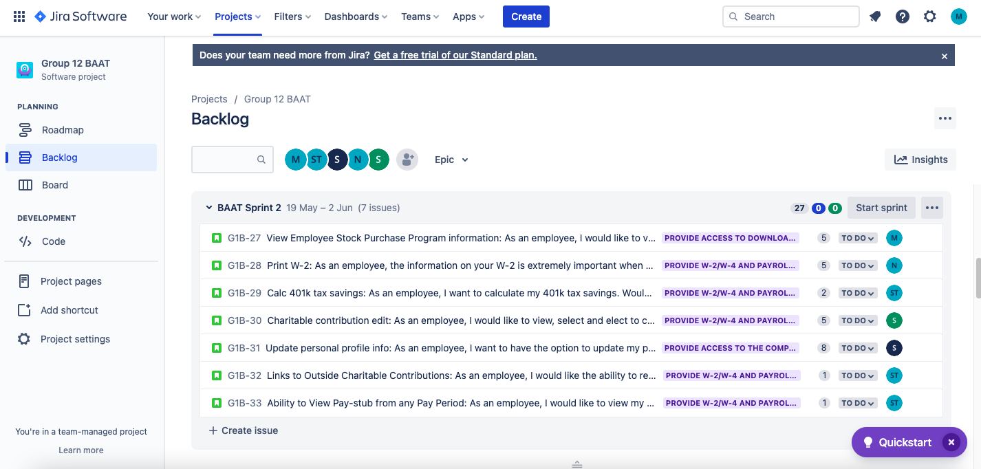

Sprint 3

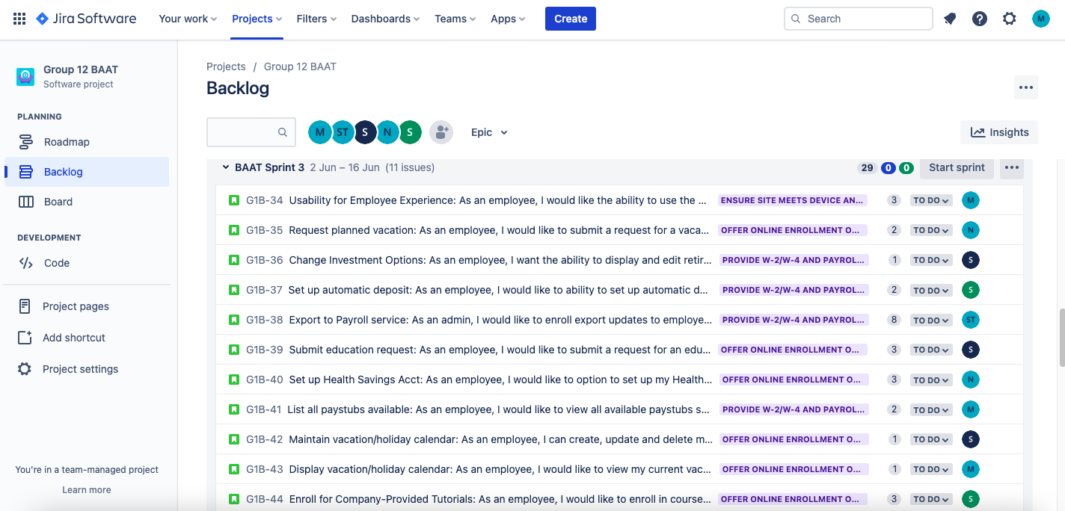

Sprint 4

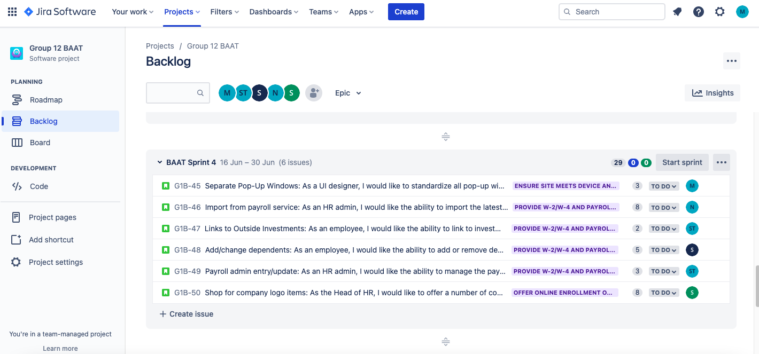

Sprint 5

Only one team member can be assigned to a user’s story. So, other members are assigned to the next sprint.

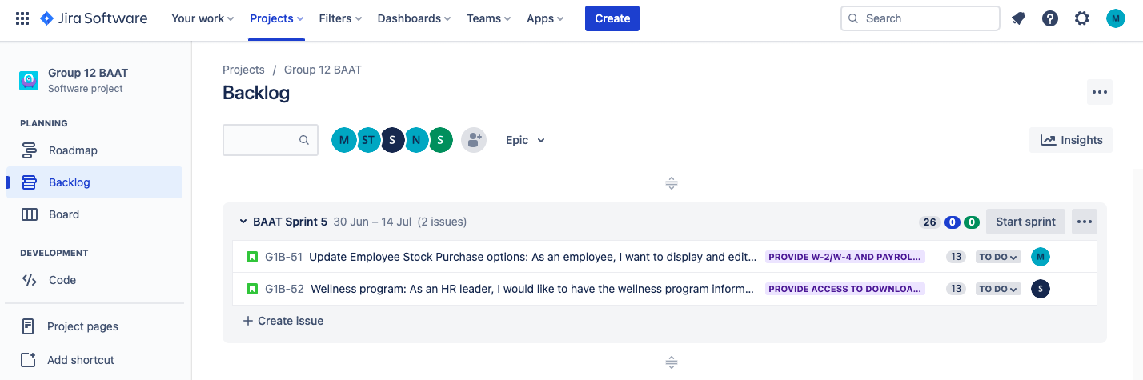

Sprint 6

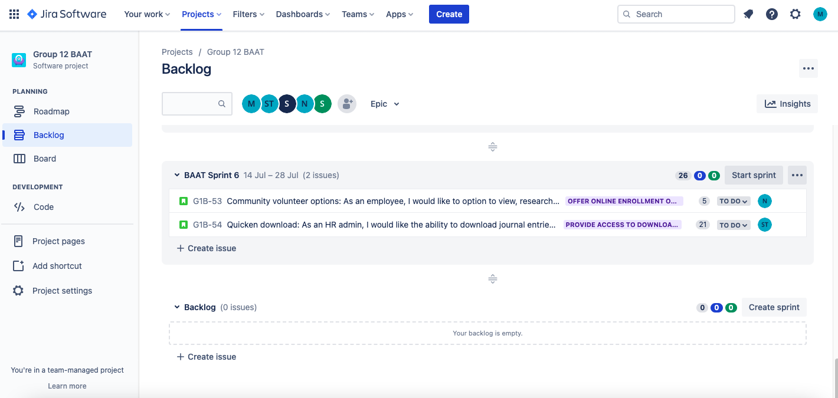

Team Members

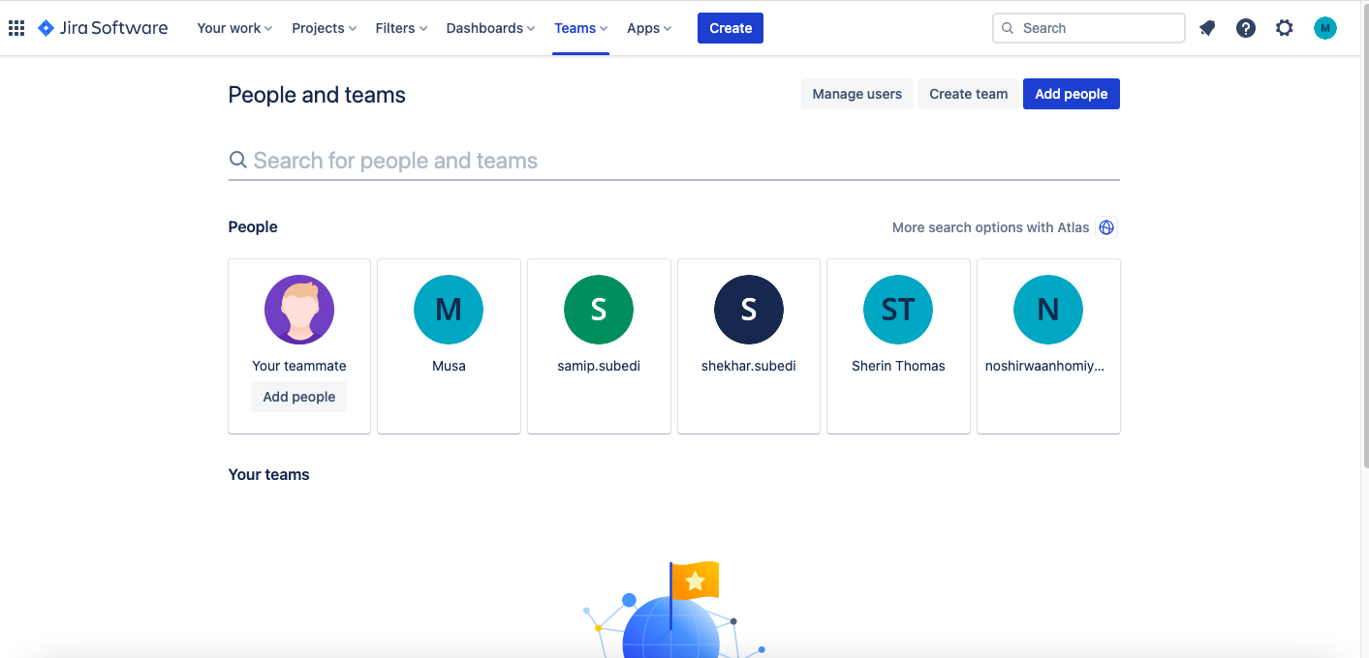

The Board (like the Kanban board) shows the progress of the project. Once the “Start sprint” button is clicked on May 5, the start date for the project, the user’s stories will populate the “TO DO” on the board. Each story can then be assigned to “NEED EXTERNAL RESOURCES” or “IN PROGRESS” when a team member starts working on it. Once work on the story is completed and ready to be delivered, the team member can assign the story to the “DONE” group.

